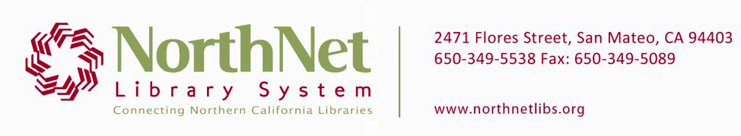
Draft Minutes

NLS Executive Committee Meeting Minutes
Adobe Connect Meeting
Wednesday, August 6, 2014

- Welcome and Roll Call: Chair Mel Lightbody called the meeting to order at 1:05 PM and welcomed attendees to the Executive Committee meeting. Present were: Lisa Dale (Vice-Chair); Mel Lightbody; Diane Smikahl; Danis Kreimeier; Michael Perry (Past-Chair); Natasha Casteel, and Victor Zazueta. Also present were Linda Crowe and Jane Light, Peninsula Library System, and Darla Gunning, California State Library.

- Public invited to address the Committee: None were present.

- Approval of the Agenda: Moved by Dale, seconded by Casteel, to approve the agenda. Motion unanimously approved.

- Consent Calendar: A. Minutes of the May 12,2014 Meeting of the NLS Executive Committee for approval: Smikahl moved, Zazueta seconded that the minutes of the Steering Committee meeting of May 12, 2014 be approved. Motion passed unanimously.

- Amending FY14/15 Budget and Plan of Service to reflect one-time augmentation:
Pending approval by the CLSA Board at its September meeting, the one time additional allocation for NLS will be $180,099 for Communications & Delivery (C&D) (including shared e-materials collections) and $45,024 for System Administration. Funds may not be spent on shared database subscriptions.

A revised CLSA Budget and Supplemental Plan of Service is due at the State Library by mid-August using forms and information provided last week in order to have materials prepared for the State Library Board’s September meeting. Lightbody noted that the extremely tight turnaround time leaves no time for conferring with the membership and considering all options.

Information from Darla Gunning was that although these one-time funds may not be used for a C&D equipment revolving fund, the baseline C&D funding may be used for that purpose. The Executive Committee has authority to amend the annual NLS budget as needed after its adoption by the Administrative Council.

The Committee discussed using some of the one-time funding for additional ebooks, Freegal (downloadable music) or other shared e-materials. Because they lacked time and information to decide what would most benefit members and their patrons, especially given the one-time nature of the augmentation, the Executive Committee decided not to allocate funds for e-materials at this time. It may do so at a later date in the fiscal year by amending the NLS budget to allocate the C&D funding differently.

Moved by Kreimeier, seconded by Casteel to amend the FY2014/2015 budget by adding the additional one time CLSA allocation of $225,123, with $180,099 to Communications and Delivery and the remainder to System Administration; allocating $180,099 of baseline C&D funds to a C&D equipment replacement revolving fund and the remainder of the base C&D funds plus the one time $180,099 C&D funds among the public library members using the previously agreed formula of 50% evenly divided among members and 50% distributed based on jurisdiction's percent of total NLS population. Motion passed unanimously.

A claim form for each library to complete that will indicate how much it plans to spend on communications, on inter-member library delivery, and on shared e-materials will be drafted by PLS staff and sent to Mel, Lisa, and Michael to review before it is distributed.

- Member Survey
The Committee reviewed a draft survey for member library directors prepared by Lisa and Mel. They plan to have the results in and compiled by the October Executive Committee meeting.

7. Review Peninsula Library System Scope of Work:
Mel Lightbody, Michael Perry, Lisa Dale and Victor Zazueta will review the PLS scope of work in its current contract with NLS for discussion at the October meeting, looking forward to the services needed in FY15/16 when the contract is concluded. It is possible that PLS may not want to continue the contract or that NLS may want to seek a new service provider or define a different scope of work.

8. Adjournment: Lightbody adjourned the meeting at 2:05 PM.

